**ASSIGNMENT 9.6**

**PROBLEM STATEMENT :**

Write a pig script to find the minimum temperature observed in a given weather station in a particular year

STEP 1: filter the data based on the minimum temperature

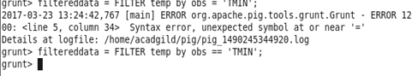

Step 2 : group the data based on the station

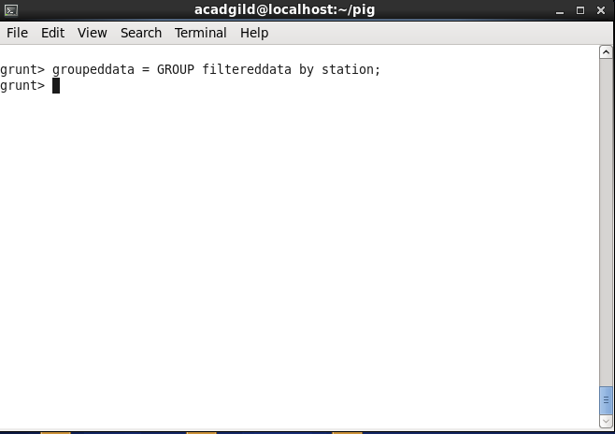

Step 3: foreach grouped data generate group

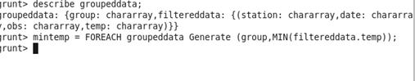

Write a pig script to find the maximum temperature observed in a given weather station in a particular year.

STEP 1: filter the data based on the maximum temperature

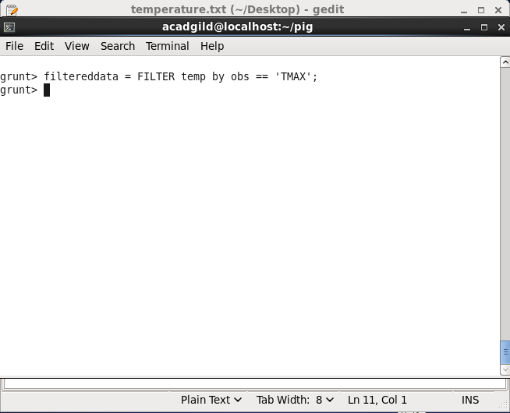

Step 2 : group the data based on the station

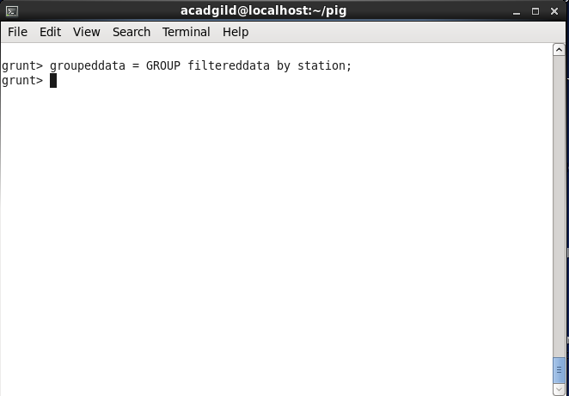

Step 3: foreach grouped data generate group

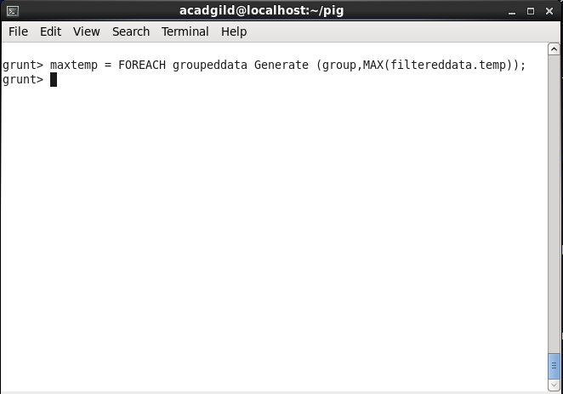

Write a pig script to find the number of readings given by each weather station according to the dataset.

Step 1: group temperature based on station

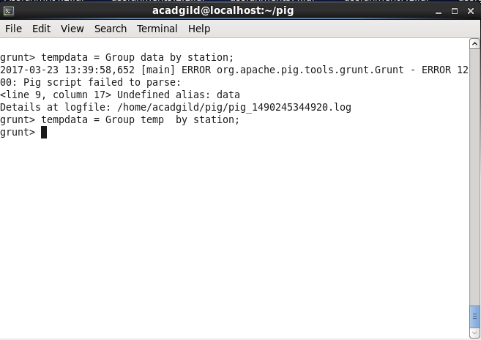

Step 2: foreach data generate the group based on count

